Requirements/Design Specification

**BI Reporting Changes 01**

Revision History

|  |  |  |  |
| --- | --- | --- | --- |
| **Date** | **Revision** | **Description** | **Author** |
| 2/18/2015 | 1.0 | Initial Version with Requirements | Roger Behm |
| 2/26/2015 | 1.1 | Updated design with Beckie’s mapping doc | Roger Behm |
| 2/27/2015 | 1.2 | Draft | Mike Boylan |
|  |  |  |  |
|  |  |  |  |

The information furnished herein by Republic Services Inc. is proprietary and confidential to Republic Services Inc. personnel and is not to be duplicated, published, or disclosed to any third party in whole or in part without permission from Republic Services, Inc.

© Copyright 2015, Republic Services Inc. - All rights reserved.

Table of contents

1 Business Requirements 6

1.1 Purpose of the Design Specification 6

1.1.1 Business Functional Requirements / Configuration 6

1.1.2 Technical Design Requirements 7

2 Assumptions 8

3 Technical Design 8

3.1 Referenced Documents 8

3.2 Process Flow and Mock Ups 8

3.3 Functional Logic 12

3.4 Data Sources & Mapping 15

3.5 InfoPro Interface 15

4 Report Changes 15

5 Technical Architecture 15

5.1 Infrastructure Considerations 15

5.2 Data Retention 15

5.3 High Availability 15

5.4 Backup, Rollback and Recover 15

6 Other Design Specifications 15

6.1 Build/Configure Standards 15

6.2 Policies and Procedures 15

6.3 Security Design 16

6.3.1 New or Existing Security 16

6.3.2 Hierarchal Data Access 16

6.3.3 Infrastructure 16

6.4 Environmental 16

7 Appendix 16

# Business Requirements

## Purpose of the Design Specification

This project will facilitate the development of transaction-level analysis and reporting using Capture data.  The successful completion of this project will result in a less labor intensive and error-prone method for transferring Capture line item level data from Capture to our BI data warehouse.  This data will then be used to support various sales and pricing initiatives including sales compensation reporting, general Capture reporting, pricing analysis, and sales agent performance analysis.  This process will replace the current reliance on the Big Machines reporting interface, which has proven to have significant load limitations and is not a viable solution for enterprise reporting.

### Business Functional Requirements / Configuration

| **Business Functional Requirement** | **Notes** |
| --- | --- |
| Create point in time snapshots of a quote during specific quote actions. | The following actions will be recorded during the lifespan of a quote, sending a snapshot to TIBCO:   1. **Created** – An item is selected for configuration within ***3) Select Service Offering*** 2. **Configured** – The quote progresses to ***4) Provide Pricing*** 3. **Submitted** – The quote progresses to ***5) Obtain Approvals***. 4. **Approved** **–** All approval levels are met within ***5) Obtain Approvals*** or no approvals are necessary and the quote progresses to ***6) Generate Documents***. 5. **Rejected** – any one approval level is rejected within ***5) Obtain Approvals.*** 6. **Finalized** – the quote is finalized and cannot be revised after completing ***7) Finalize Quote***.   Note that status can move back and forth as the user moves back and forth through the quote. |
| A list of reportable fields will be used to build the BI Capture tables | * Please see attached mapping document * The key for the header data will be quoteNumber_quote, _last_modified_date (timestamp) and reportingStatus_quote (not yet created) . * The key for the detail will remain the same pul the reportingStatus_quote |

### Technical Design Requirements

| **Technical Design Requirement** | **Notes** |
| --- | --- |
| Within Capture create variable reportingStatus_quote. | This variable should be populated based on the following actions:   1. **Created**  - when all of the following conditions are met:   1) No status exists for the quote  2) One of the following buttons/icons in *3) Select Service Offering* are clicked:  a) ***Small Container***  b) ***Large Container***  c) ***Additional Items***  d) ***Next*** under *Change Existing Services*  (only applies when *Sales Activity* is set  to *Existing Customer* and *Change of*  *Owner*)   1. **Configured** – when either of the following conditions are met:    1. The ***Next*** button is clicked within *3) Select Service Offering*.    2. The ***Next*** button is clicked within the line item grid for *Additonal Items*. 2. **Submitted** - when the ***Submit*** button is clicked within the *Submit Comment* dialog box. 3. **Approved** - when either of the following conditions are met:    1. No approvals are necessary and the ***Next*** button is clicked in *4) Provide Pricing*    2. All green check mark icons have been clicked within *5) Obtain Approvals* 4. **Rejected** – when any red X mark icon has been clicked within *5) Obtain Approvals*. 5. **Finalized** – when the ***Finalize*** button is clicked within *7) Finalize Quote*.   XML must be sent to TIBCO only after all action processing has been complete and the reportingStatus_quote variable has been correctly set.  The ***Previous, Reconfigure*** and ***Revise*** buttons will never change status on their own. Status will only change according to the conditions above as the user moves forward from the landing spot after clicking ***Previous, Reconfigure*** or ***Revise***. See assumptions for justifications. |
| Send quote information to InfoPro | TIBCO will continue to send InfoPro quotes but only if the isSaleFinalized_quote is equal to True (1) |
| Sending qutoes to BI | TIBCO will send all quotes it received to BI |

# Assumptions

* 1. Any quote with status ***Work in Progress*** before this functionality is implemented will not have status set or XML sent to TIBCO unless it is opened and one of the operations described in **TDR-001** is completed inside the quote.
  2. Any quote started will not receive a status or send XML to TIBCO until configuration starts as described in **TDR-001.**
  3. Leaving the quote at any point will have no effect on status .
  4. Moving back through a quote using the ***Reconfigure***, ***Previous*** or ***Revise*** buttons will have no effect on status until one of the operations described in **TDR-001** is completed.
  5. Re-assigned and claimed quotes will go through the normal process described in **TDR-001.**

# Technical Design

## Referenced Documents

None

## Process Flow and Mock Ups

The following screen shots show where status is affected:

**Created**

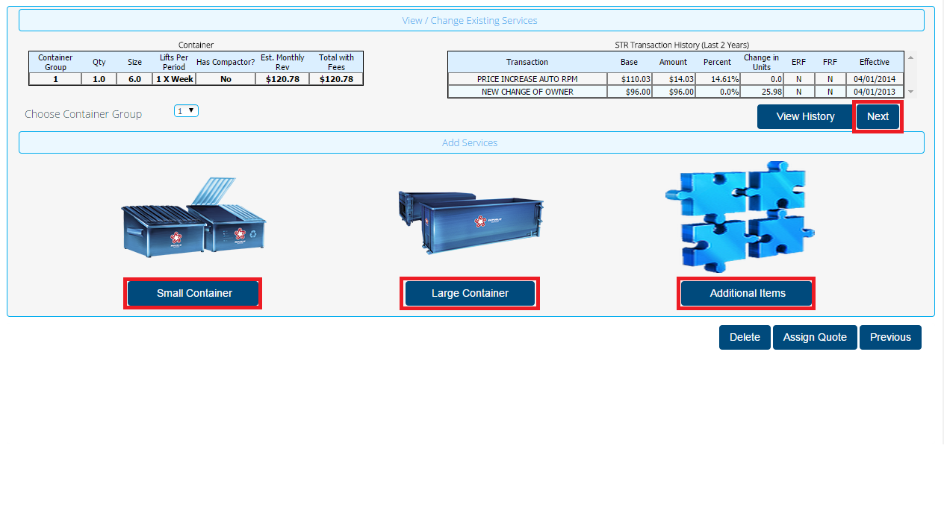

**Configured**

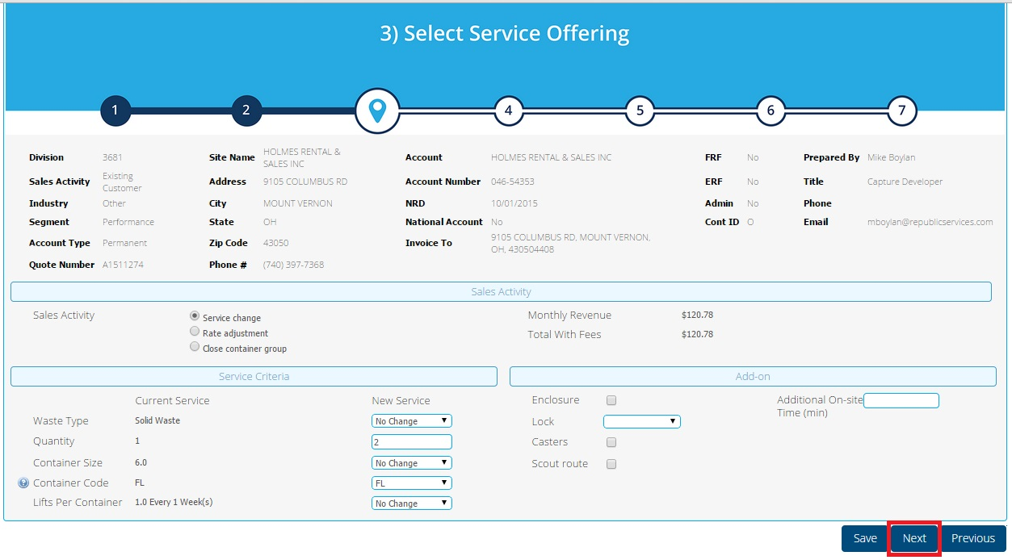

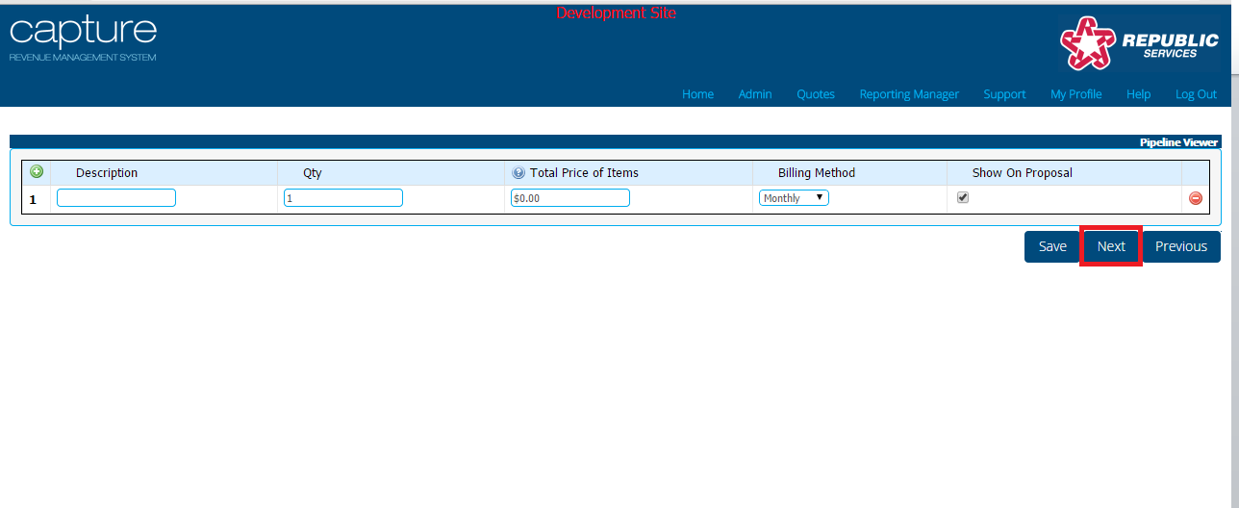

**Submitted**

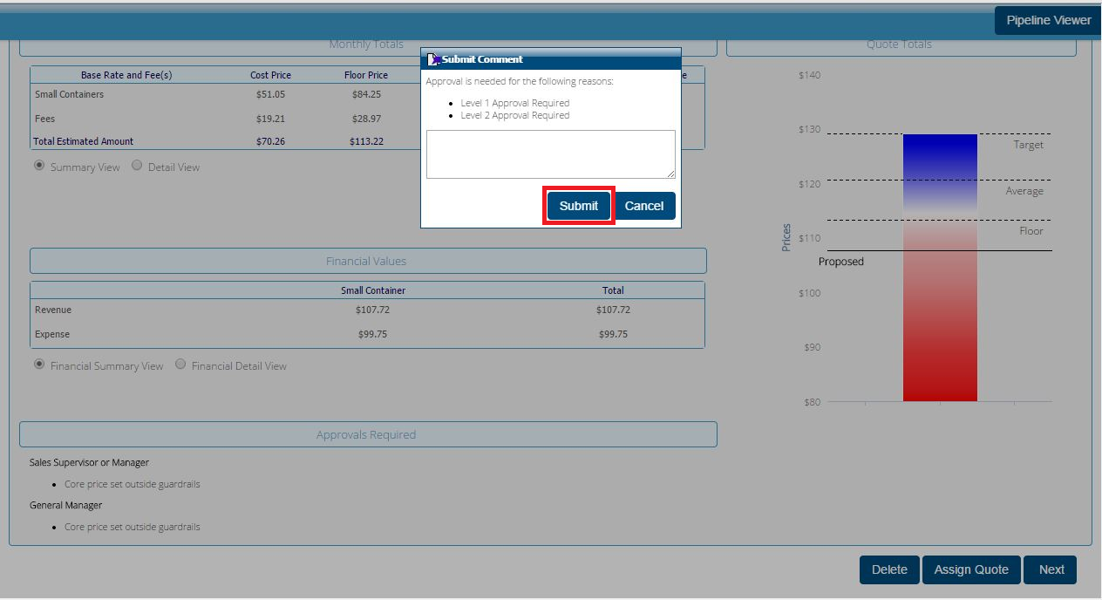

**Approved**

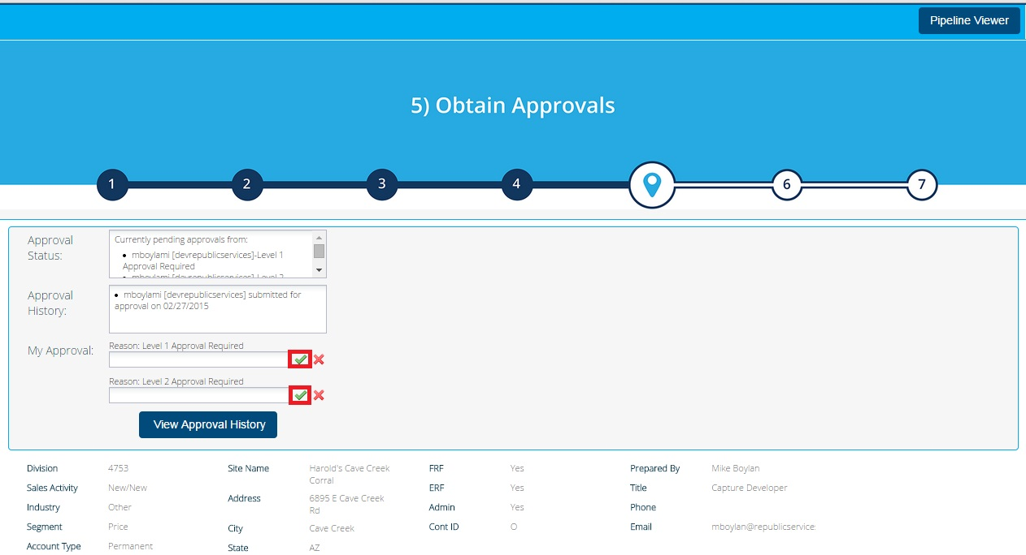

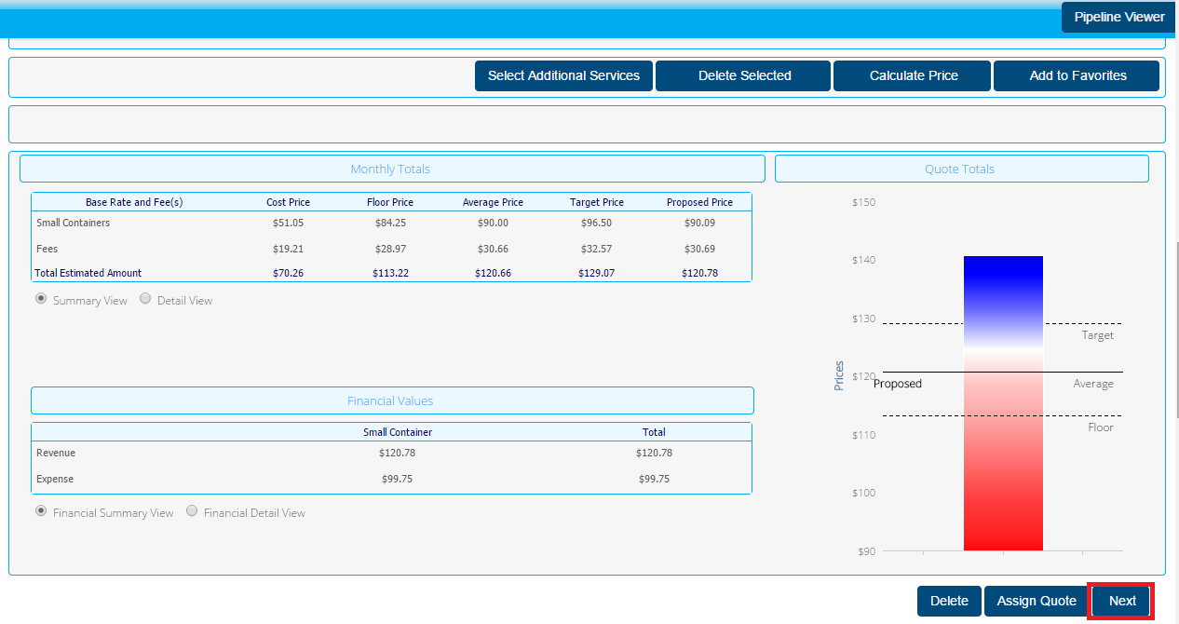

**Rejected**

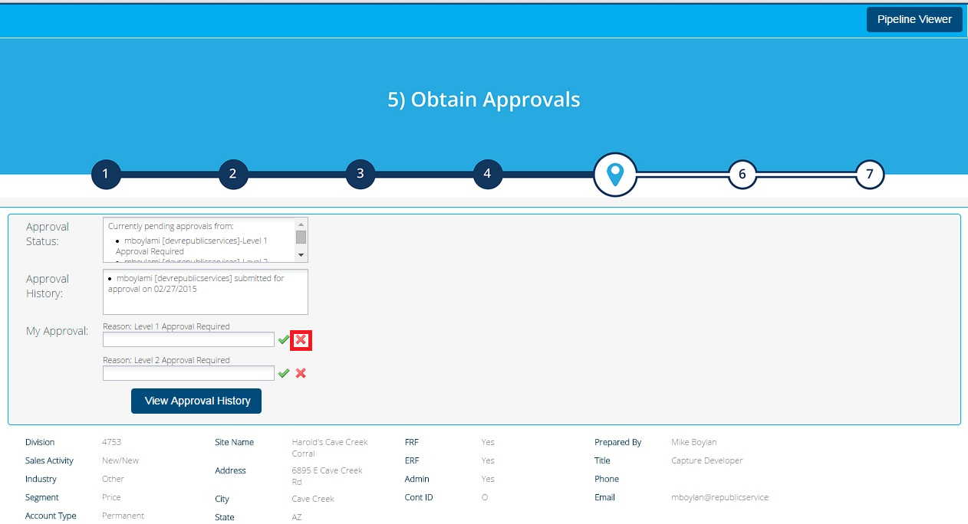

**Finalized**

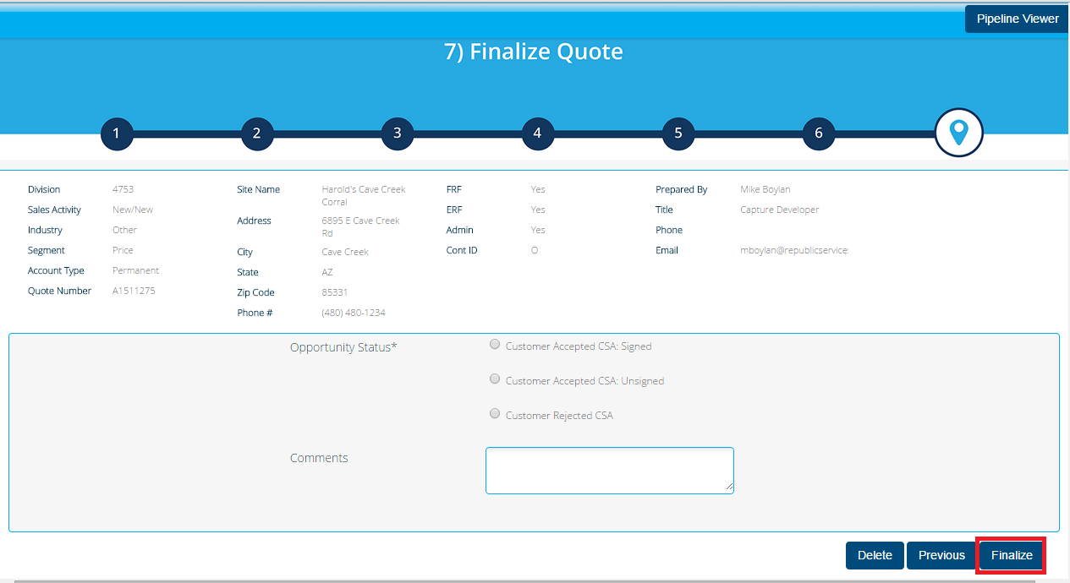

## Functional Logic

Listed are the forward actions where the Quote XML will be sent to TIBCO:

1. **Created**

The following actions must trigger an XML Notification for all Sales Activity types, if reportingStatus_quote is not set:

Small Container – addLineItems_quote

Large Container – largeContainer

Additional Items –addAdhocItems

The following action must trigger and XML Notification for Change of Owner and Existing Customer, if

reportingStatus_quote is not set:

Next – changeServices_quote

2. **Configured**

Send XML in step – Select Services

Admin

Hidden Action

Hidden Action: Select Services -> Adjust Pricing

Next

Next: Select Services -> Adjust Pricing

Exec Manager

Hidden Action

Hidden Action: Select Services -> Adjust Pricing

Next

Next: Select Services -> Adjust Pricing

Manager

Hidden Action

Hidden Action: Select Services -> Adjust Pricing

Next

Next: Select Services -> Adjust Pricing

Sales Rep

Hidden Action

Hidden Action: Select Services -> Adjust Pricing

Next

Next: Select Services -> Adjust Pricing

Return to Pricing???

Calculate Price???

Send XML in step – Add or Change Services

Admin

Hidden Action

Hidden Action: Add or Change Services -> Adjust Pricing

Next

Next: Select Services -> Adjust Pricing

Exec Manager

Hidden Action

Hidden Action: Add or Change Services -> Adjust Pricing

Next

Next: Select Services -> Adjust Pricing

Manager

Hidden Action

Hidden Action: Add or Change Services -> Adjust Pricing

Next

Next: Add or Change Services -> Adjust Pricing

Sales Rep

Hidden Action

Hidden Action Add or Change Services -> Adjust Pricing

Next

Next: Select Services -> Adjust Pricing

Send XML in step – Add Additional Services - New

Admin

Hidden Action

Hidden Action: Add or Change Services -> Adjust Pricing

Next

Next: Select Services-> Adjust Pricing

Exec Manager

Hidden Action

Hidden Action: Add or Change Services -> Adjust Pricing

Next

Next: Select Services -> Adjust Pricing

Manager

Hidden Action

Hidden Action: Add or Change Services -> Adjust Pricing

Next

Next: Select Services -> Adjust Pricing

Sales Rep

Hidden Action

Hidden Action Add or Change Services -> Adjust Pricing

Next

Next: Select Services -> Adjust Pricing

3. **Submitted**

Send XML in step – Adjust Pricing

Admin

Request Approval

Request Approval: Apply Pricing -> Submitted for Approval

Exec Manager

Request Approval

Request Approval: Apply Pricing -> Submitted for Approval

Manager

Request Approval

Request Approval: Apply Pricing -> Submitted for Approval

Sales Rep

Request Approval

Request Approval: Apply Pricing -> Submitted for Approval

4. **Approved**

Send XML in step – Adjust Pricing

Admin

Next

Submit: Apply Pricing -> Generate Documents

Exec Manager

Next

Submit: Apply Pricing -> Generate Documents

Manager

Next

Submit: Apply Pricing -> Generate Documents

Sales Rep

Next

Submit: Apply Pricing -> Generate Documents

Send XML in step – Submitted for Approval

Admin

Next

Submit: Submitted for Approval -> Generate Documents

Exec Manager

Next

Submit: Submitted for Approval -> Generate Documents

Manager

Next

Submit: Submitted for Approval -> Generate Documents

Sales Rep

Next

Submit: Submitted for Approval -> Generate Documents

5. **Rejected**

Send XML in step – Submitted for Approval

Admin

Reject

Reject: Obtain Approval -> Adjust Pricing

6. **Finalized**

The functionality to send XML already exists.

## Data Sources & Mapping

For detailed mapping information, please refer to the BMI [Enterprise Mapping Document](http://itpmo-2013projects/Pricing%20Initiative/2.0%20Planning%20and%20Requirements/BMI%20Enterprise%20Mapping%20Document.xlsx).

## InfoPro Interface

No change. InfoPro will continue to receive the same data from TIBCO

# Report Changes

No Changes

# Technical Architecture

## Infrastructure Considerations

No changes to infrastructure.

## Data Retention

No changes to data retention.

## High Availability

Not Applicable.

## Backup, Rollback and Recover

No changes to backup and recovery procedures.

# Other Design Specifications

## Build/Configure Standards

Reference Aldon procedures for Capture.

## Policies and Procedures

Conforms to all published IT policies and procedures.

## Security Design

### New or Existing Security

No Changes.

### Hierarchal Data Access

No Changes.

### Infrastructure

No Changes.

## Environmental

No Additional environmental requirements.

# Appendix